LBYCPEI

**Object-Oriented Programming Laboratory**

©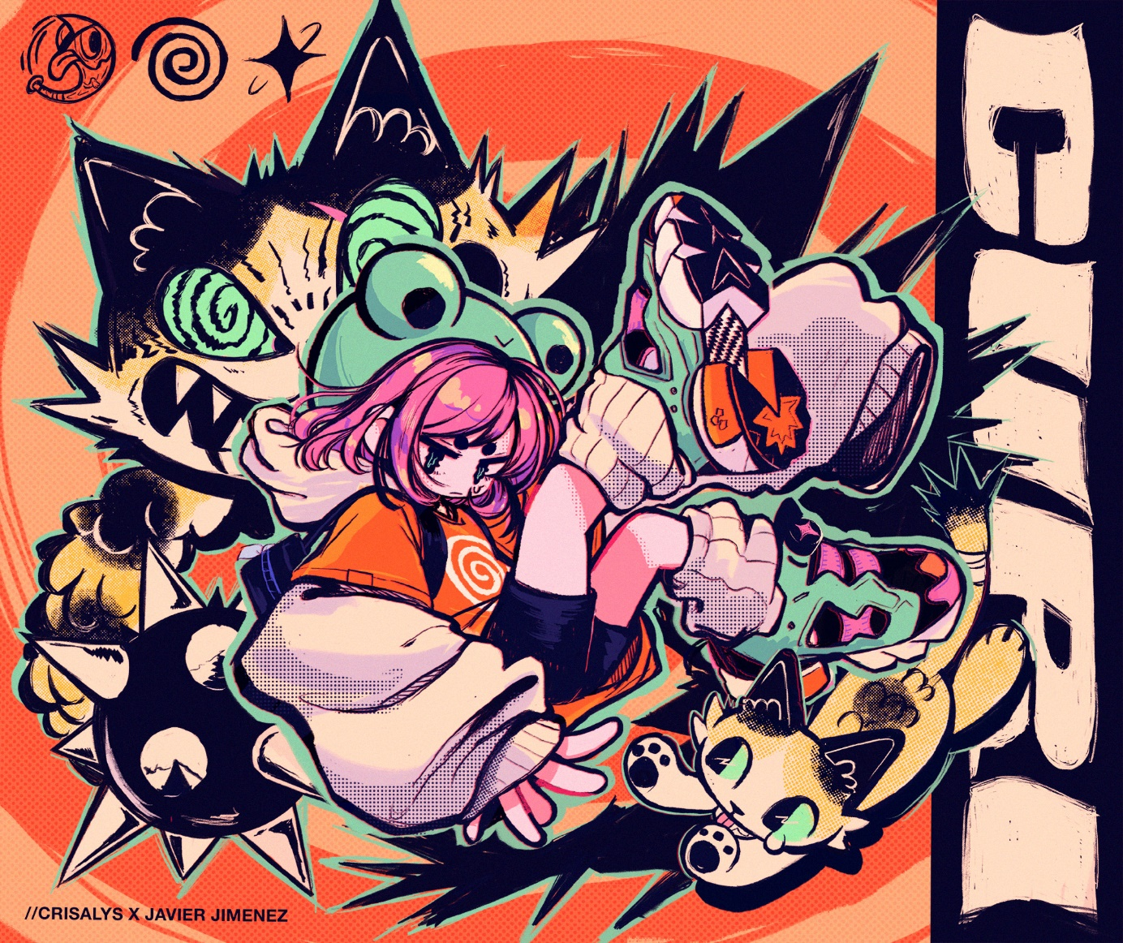

Art by @Criisalys: https://twitter.com/Criisalys/status/1679603409261936643?s=20

**Preliminary Report for Laboratory Activity 7**

Java Programming Language Fundamentals

By

Jay Michael T. Carlos, LBYCPEI-EQ8

# DELIVERABLE EVIDENCE (Screenshots or Image files)

1. Default view

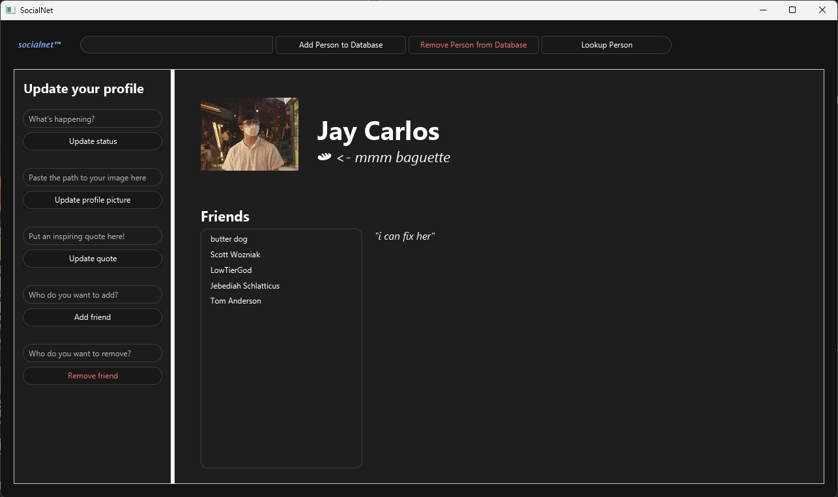

1. Update status

1. Update profile picture

1. Update quote

1. Update quote

1. Remove friend

1. Add friend

1. Search for person

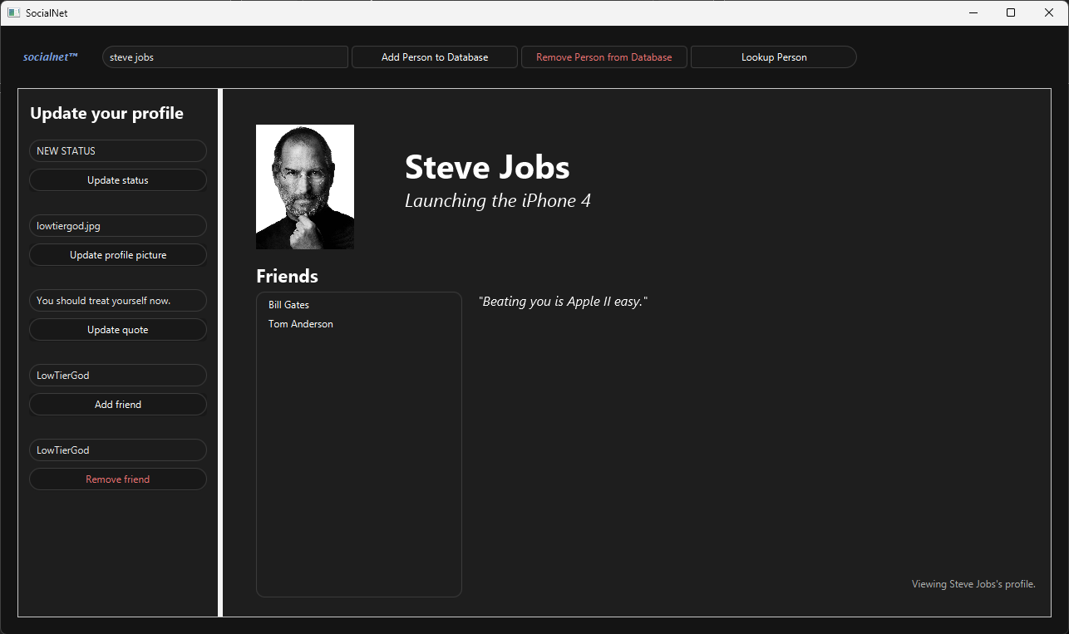

1. Remove person from database

1. Add person to database

